1.2. Design and Analysis of a Butterworth IIR High-Pass Filter Using MATLAB.

CODING:
clc;
clear;
close all;

% Specifications
Fs = 10000; % Sampling Frequency
Fp = 3000; % Passband Frequency
Fst = 2000; % Stopband Frequency
Rp = 1; % Passband Ripple (dB)
Rs = 60; % Stopband Attenuation (dB)

% Butterworth High-Pass Filter Design
[N,Wn] = buttord(Fp/(Fs/2),Fst/(Fs/2),Rp,Rs);
[b,a] = butter(N,Wn,'high');

% Magnitude & Phase Response
figure;
freqz(b,a);
title('Magnitude and Phase Response');

% Impulse Response
figure;
[h,n] = impz(b,a,50);
stem(n,h,'filled');
grid on;
title('Impulse Response');
xlabel('Samples');
ylabel('Amplitude');

% Step Response
figure;
x = ones(1,50); % Unit step input
y = filter(b,a,x); % Step response
stem(0:49,y,'filled');
grid on;
title('Step Response');
xlabel('Samples');
ylabel('Amplitude');

% Group Delay
figure;
grpdelay(b,a);
title('Group Delay');

% Pole-Zero Plot
figure;
zplane(b,a);
title('Pole-Zero Plot');

% Display Results
fprintf('Minimum Filter Order (N) = %d\n', N);
fprintf('Cutoff Frequency (Wn) = %.4f\n', Wn);

OUTPUT: 1
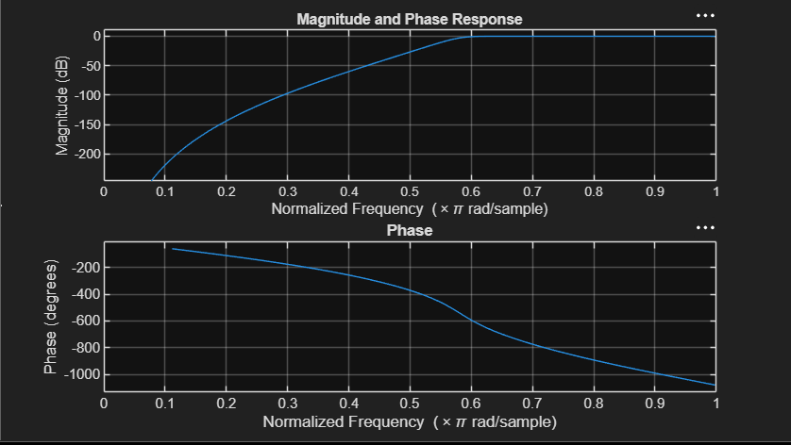

OUTPUT: 2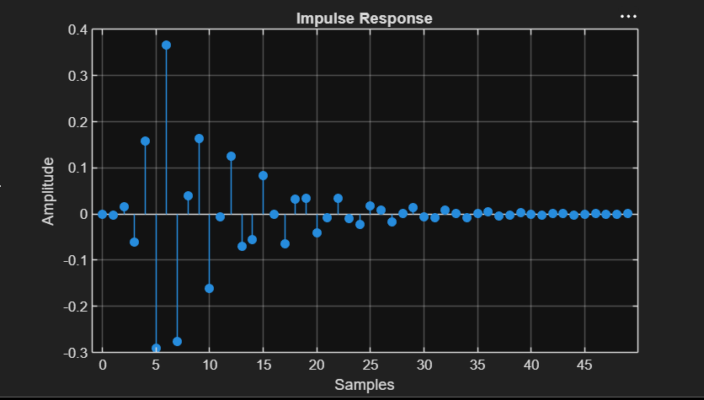

OUTPUT: 3
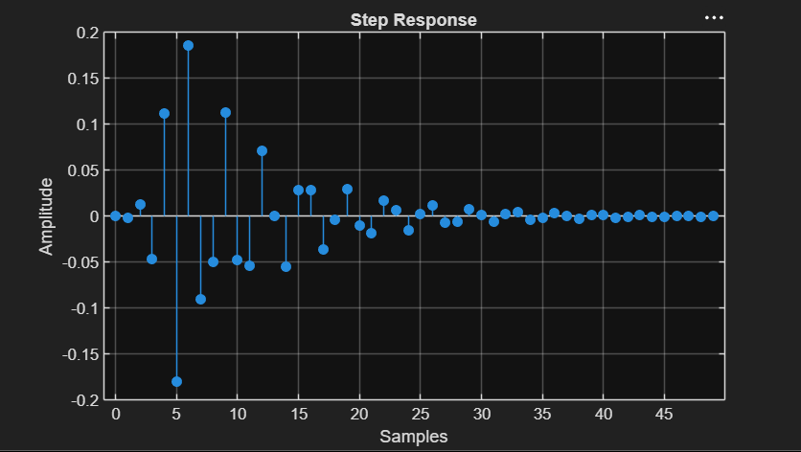

OUTPUT: 4
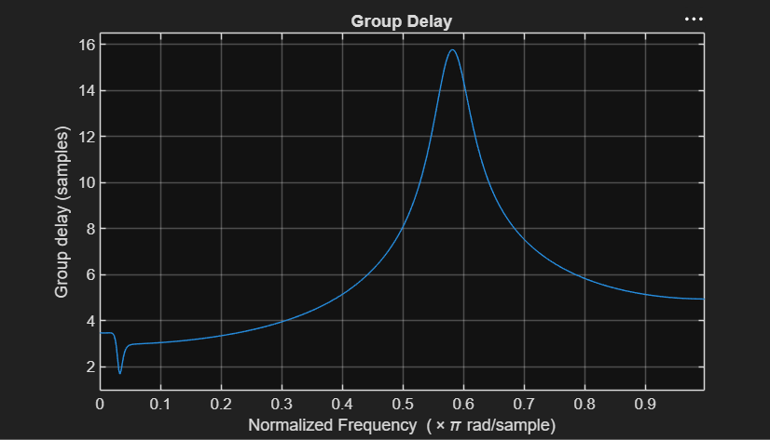

OUTPUT: 5
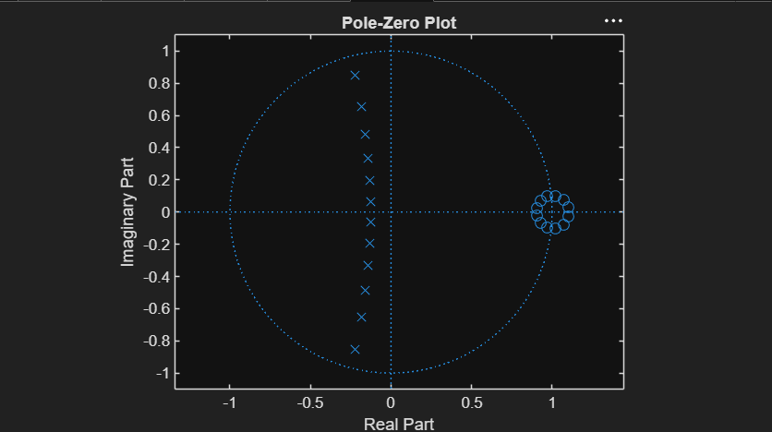

RESULT:
Minimum Filter Order (N) = 12
Cutoff Frequency (Wn) = 0.5807

